DATE-29/08/2022

192110552

1. C++ program to Adding two numbers

PROGRAM-

#include<iostream>

using namespace std;

int main()

{

int x=5,y=5;

cout<<x+y;

}

OUTPUT-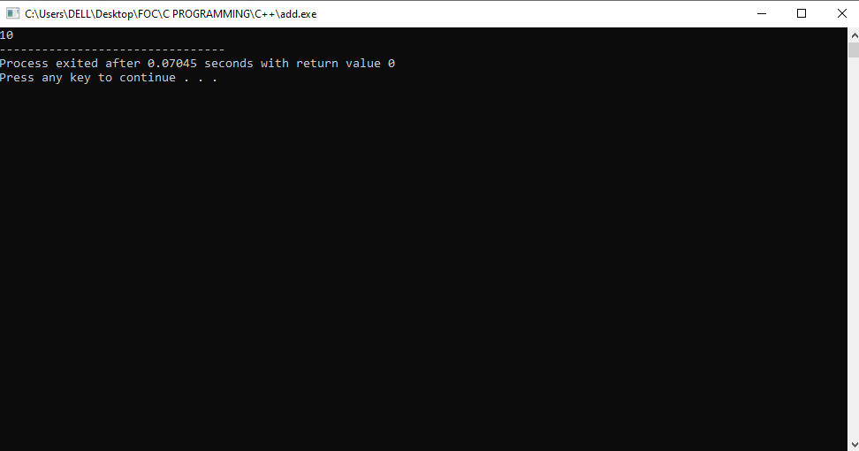

1. C++ PROGRAM TO CHECK THE ELIGIBILITY OF VOTE

CONDITIONS:

1. ENTERED NUMBER SHOULD BE POSITIVE
2. ENTERED VALUE SHOULD BE INTEGER

PROGRAM-

#include<iostream>

using namespace std;

int main()

{

int age;

cin>>age;

if(age>0 && int(age))

{

if(age>=18)

{

cout<<"eligible for vote";

}

else

{

cout<<"not eligible to vote";

}

}

else

{

cout<<"invalid input";

}

return 0;

}

OUTPUT-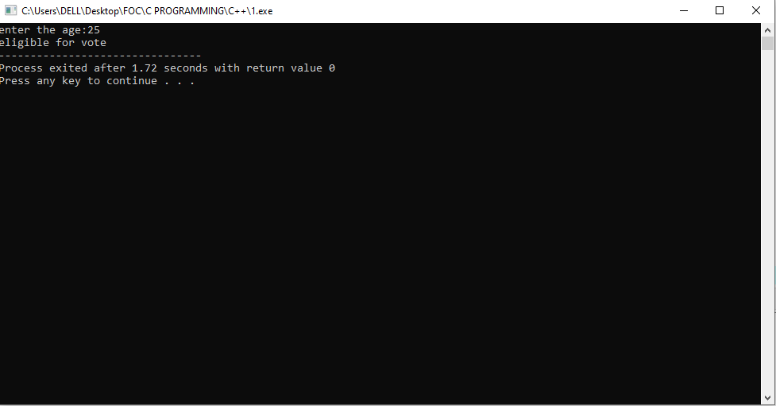

1. C++ PROGRAM FOR FINDING AREA AND CIRCUMFERENCE OF CIRCLE USING SWITCH CASE

PROGRAM-

#include <iostream>

using namespace std;

int main()

{

int ch,r;

cout<<"enter the choice:";

cin>>ch;

cout<<"enter the radius:";

cin>>r;

switch(ch)

{

case 1:

{

cout<<"area of circle is"<<3.14\*r\*r;

break;

}

case 2:

{

cout<<"circumference of the circle is"<<2\*3.14\*r;

}

default:

{

cout<<"enter correct radius";

}

}

}

OUTPUT-

